TG/118/3
Endive/Andyvie, 2001-06-06

Reference Number/Verwysingsnommer
(for office use/vir kantoorgebruik)

TECHNICAL QUESTIONNAIRE
to be completed in connection with an application for a plant breeder’s right

TEGNIESE VRAELYS
om saam met ‘n aansoek om planttelersregte voltooi te word
1. Species/Spesie Cichorium endivia L.

ENDIVE

ANDYVIE
- Applicant (Name and address of local company/organisation)
Aansoeker (Naam en addres van plaaslike firma/organisasie)

Tel.: ……………………………. Fax/Faks: ………………………….
Contact person/Kontakpersoon: …………………………………………………….
- Proposed denomination or breeder’s reference

Voorgestelde benaming of telersverwysing

Commercial name (if applicable)
Kommersiële naam (indien van toepassing)

4. Information on origin, maintenance and reproduction of the variety

Inligting oor oorsprong, instandhouding en voortplanting van die variëteit

4.1 Origin and breeding method/Oorsprong en telingsmetode
(a) Imported from/Ingevoer vanaf [ ]
………………………………………….
(b) Bred locally/Plaaslik geteel [ ]

4.2 Other information/Ander inligting
(a) Has this variety been sold or marketed in South Africa previously?
Is hierdie variëteit al voorheen in Suid-Afrika verkoop of bemark?
Yes/Ja [ ] No/Nee [ ]
If yes, indicate where and when/Indien ja, dui aan waar en wanneer:
………………………………………………………………….



5. Characteristics of the variety to be indicated (the number in brackets refers to the corresponding characteristic in the Test Guidelines; please mark the state of expression which best corresponds)./ Kenmerke van die variëteit wat aangetoon moet word (die nommer in hakies verwys na die ooreenstemmende kenmerk in die UPOV-riglyne); merk asseblief in die toepaslike spasie by die ooreenstemmende kenmerk.

Characteristics/ Example Varieties/ Note/
Kenmerke Voorbeelde Nota
5.1 Heart: shape in longitudinal section
(3) Hart: vorm in lengtesnee
elliptic/ellipties 1[ ]
transverse broad elliptic/afgeplat breed ellipties 2[ ]
transverse narrow elliptic/afgeplat smal ellipties 3[ ]

5.2 Heart: color
(4) Hart: kleur
yellowish green/gelerig groen 1[ ]
green/groen 2[ ]
5.3 Leaf: color
(12) Blaar: kleur
yellowish green/gelerig groen 1[ ]
green/groen 2[ ]
greyish green/gryserig groen 3[ ]
5.4 Leaf: dissections
(14) Blaar: insnydings
absent (plain type)/afwesig (gewone tipe) 1[ ]
present (cut & intermediate types)/teenwoordig (sny-andyvie & intermediêre tipes) 9[ ]
5.5 Only varieties of cut endive and intermediate types:
(15) Leaf: degree of dissection
Slegs sny-andyvie en intermediêre tipes:
Blaar: mate van insnydings
type/tipe 1 1[ ]
type/tipe 2 2[ ]
type/tipe 3 3[ ]
5.6 Flower: color
(29) Blom: kleur
white/wit 1[ ]
pink/pienk 2[ ]
blue/blou 3[ ]
violet blue/blou-pers 4[ ]
5.7 Time of bolting
(31) Tyd van saadskiet
early/vroeg 3[ ]
medium 5[ ]
late/laat 7[ ]
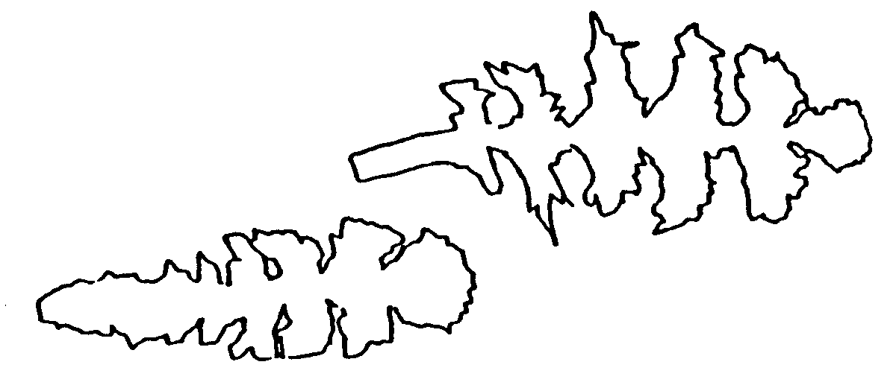
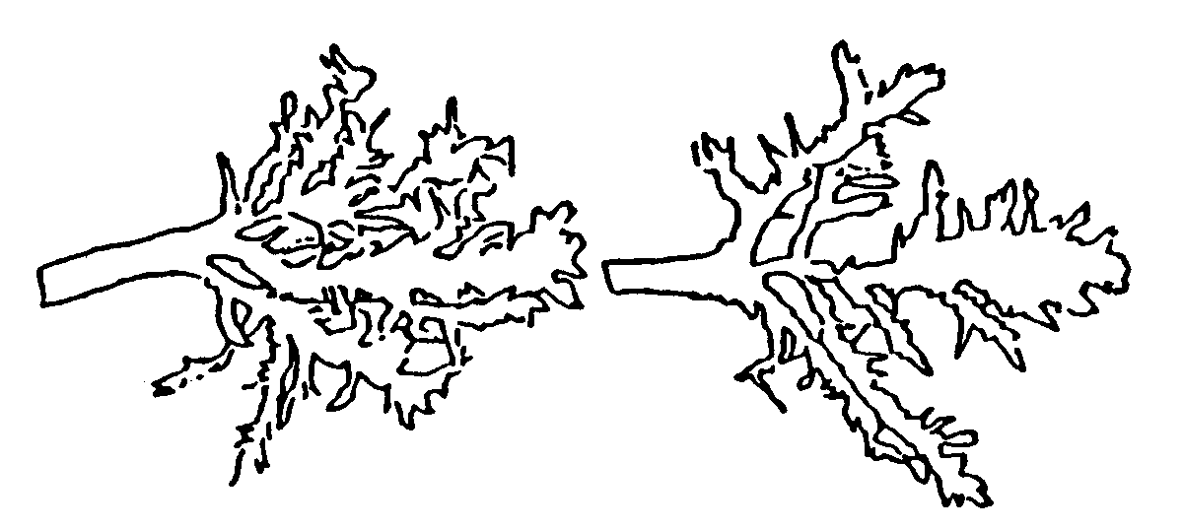
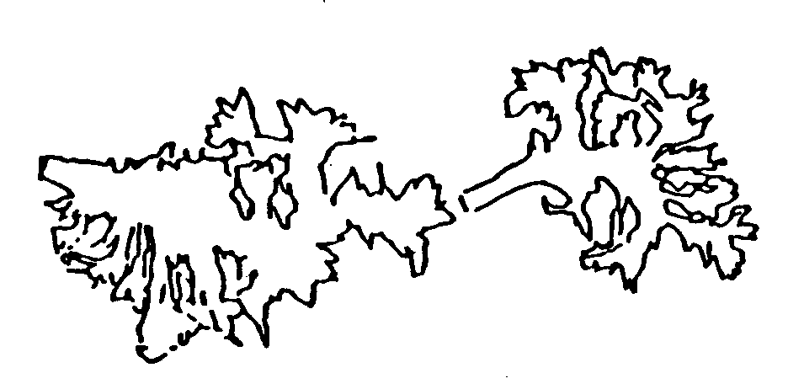

6. Similar varieties and differences from these varieties (varieties known in South Africa)

Soortgelyke variëteite en verskille van hierdie variëteite (variëteite bekend in Suid-Afrika)
Denomination of Characteristic in State of expression of State of expression of
similar variety/ which the similar similar variety/ candidate variety/
Benaming van soort- variety is different º)/ Uiting van kenmerk Uiting van kenmerk
gelyke variëteit Kenmerk waarin soort- van soortgelyke variëteit van kandidaatvariëteit
gelyke variëteit verskilº)

_____________________
º) In the case of identical states of expressions of both varieties, please indicate the size of the difference.
In geval van identiese uiting van kenmerke van beide variëteite, dui asb. die grootte van die verskil aan.
7. Additional information which may help to distinguish the variety/

Addisionele inligting wat kan help om die variëteit te onderskei
7.1 Resistance to pests and diseases/Weerstand teen siektes en plae

7.2 Special conditions for the examination of the variety

Spesiale toestande vir die ondersoek van die variëteit

7.3 Other information/Ander inligting

8. Authorization for release/Magtiging vir vrystelling
(a) Does the variety require prior authorization for the release under legislation concerning the protection of the environment, human and animal health?
Benodig die variëteit vooraf magtiging vir vrystelling onder wetgewing wat die omgewing, mens- en dieregesondheid beskerm?
Yes/Ja [ ] No/Nee [ ]
(b) Has such authorization been obtained?
Is sulke magtiging verkry?
Yes/Ja [ ] No/Nee [ ]
If the answer to that question is yes, please attach a copy of such an authorization.
Indien die antwoord ja is, heg asseblief ‘n afskrif van die magtiging aan.

Signature ……………………………………….. Date ………..…………………
Handtekening Datum

